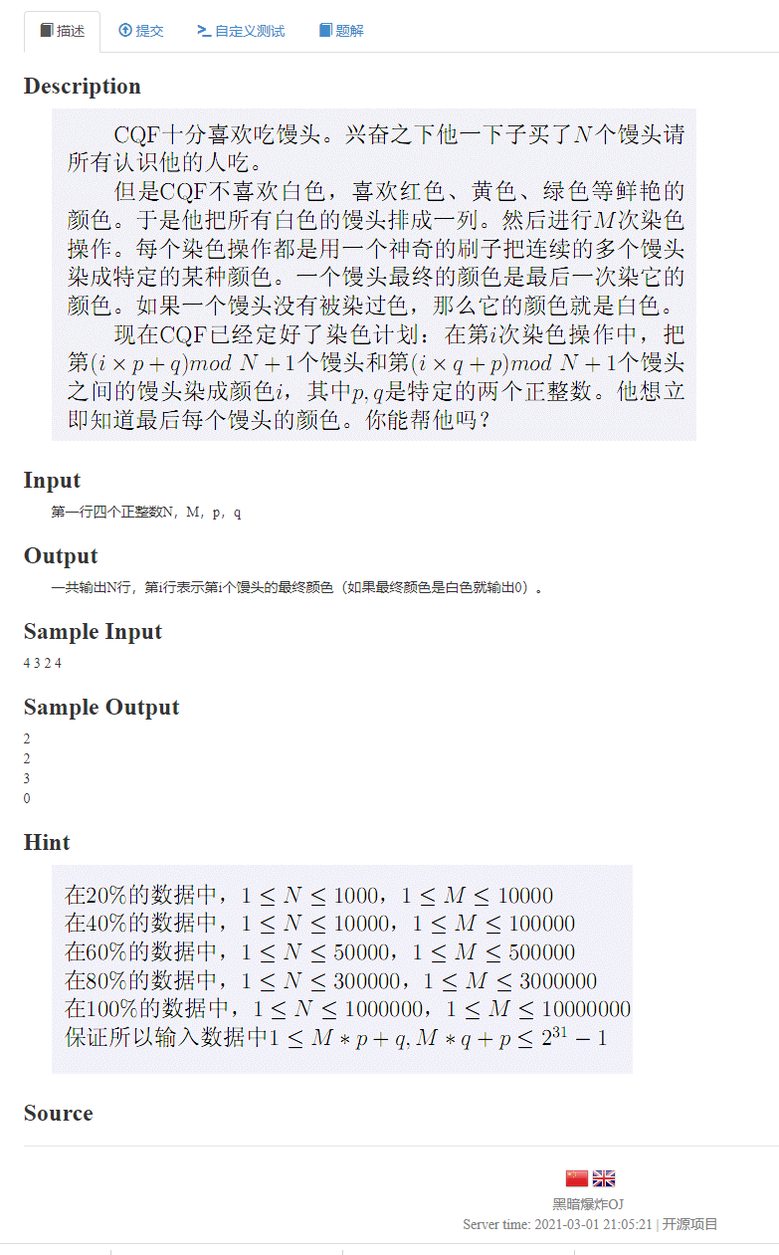

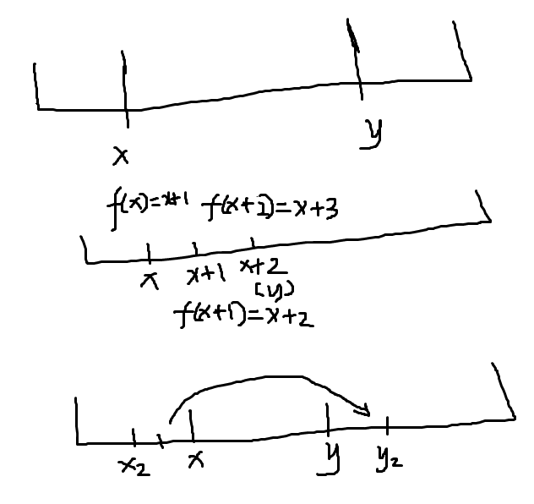
并查集标记区间的原理就是这样，适用于点的总数《=1e6的情况

#include<bits/stdc++.h>
#define ll long long
using namespace std;
const int N=1000006;
int f[N];
int find1(int x)
{
if(f[x]==x) return x; else return f[x]=find1(f[x]);
}
int col[N];
int main()
{
ll n,m,p,q;
scanf("%lld %lld %lld %lld",&n,&m,&p,&q);
for(int i=1;i<=n+2;i++) f[i]=i;
int k=0;
for(int i=m;i;i--)
{
ll x=(i*p%n+q)%n+1;
ll y=(i*q%n+p)%n+1;
if(x>y) swap(x,y);
for(int now=find1(x);now<=y;now=find1(now))
{
col[now]=i; f[now]=now+1; k++;
if(k>=n) break;
}
}
for(int i=1;i<=n;i++)
printf("%d\n",col[i]);

return 0;
}

